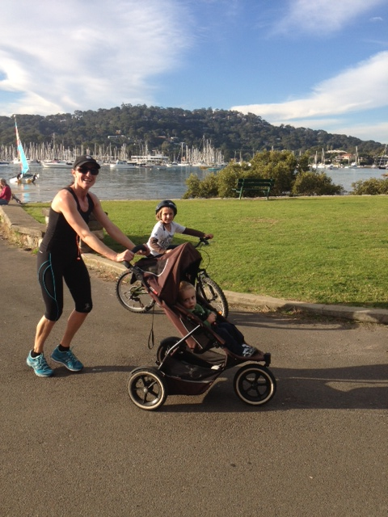
Are you FIT for your project?
By Maja Kowalski, PMI Sydney Chapter Communications Director
Yes, I’m crazy about fitness!
It helps me not only stay strong and healthy but also focussed, disciplined, and inspired. And, those three attributes are so important in project management … well, really in everything we do in life!

Focus
Without focus, there is no project – because projects are all about achieving objectives. When you lose focus, you lose sight of where you are heading for. As a project manager, you are a people leader. Your team’s focus depends on you being focussed. Stay focussed like a 100m sprint runner – it only takes a split second to lose the race… and if it’s the Olympics you will have to wait another 4 years to get another chance! Think about your project like a sprint race – you can’t afford to lose focus.
Discipline
Do you procrastinate? Do you let your project commitments slip because (you think) there is no real pressure to deliver? Do you catch yourself doing a ‘half-jobbie’ from time to time? If the answer is yes, then it’s time to get yourself into shape. As project managers, our job is to deliver a desired outcome, to lead a team towards the set objectives, and to co-ordinate and complete the required activities in a disciplined manner and with the highest quality possible (yes, remember the balancing act of scope, time, cost and quality!). This applies to everything and anything we do, from solid planning, stakeholder engagement, meetings, project documentation, status reporting, risk and issues management through cost management, change control through to team leadership, communication and Post Implementation Reviews. Without discipline, your project is likely to go off-track very quickly.
Inspiration
Inspiration is what makes us get up in the morning and what drives us to take the next step, overcome hurdles and progress towards the set goals. So, how do I find my inspiration? Purely thinking about all those people who are less fortunate and still achieve a lot more than most of us who have it pretty good in life. The kids who live in the villages of Peru, Sri Lanka, Nepal, who walk to school and back for 4hrs+ every day, do housework, look after their siblings and still study hard, and are the happiest and most appreciative students on Earth. And many others who conquer every day of their lives, and reach the summit despite all the odds and all the rocks that life throws at them. And, once they get to the top of their mountain, they go for the clouds… I always wonder what inspires those people to go on and fight to get where they want to be. And, this is enough for me to get on the road and run 10kms pushing a pram and encouraging a six year old to cycle hard up the hill (lots of motivational speaking involved there), do marathons, triathlons and ocean swims … breast stroke as I’m hopeless at free style! This is what inspires me to get through the roadblocks I come across on my projects, work through the issues, keep the team’s spirits up, and never ever give up.
Next time you encounter a challenge on your project, look at it as an opportunity to apply and showcase your skills, strengths and knowledge rather than a risk to fail. But to achieve that state of mind you must Stay Focussed, Disciplined and Inspired. Get FIT - Find Inspiration Today!

